**Project 1**

1. Project Charter

2. Table of Contents (will template for future)

3. Revision History

4. Meeting Minutes

|  |  |  |
| --- | --- | --- |
| Meeting Number: | Date of Meeting | Time Of Meeting |
| 1 | 2/3/21 | 1 hour, 45 mins |
| 2 | 2/10/21 | ??? |
|  |  |  |

5. Project Plan

**6.** **Iteration 1**

6.1. Inception 1

6.1.1. UP Phase

6.1.2. Evolutionary Requirements in Iterative Methods

6.1.3. UP Artifact Influence

6.1.4. Matrix Table

6.1.5. Vision and Business Case

6.1.5.1. Vision Statement

We have employed your knowledge and skills in hopes to produce a fully functional mobile application designed as something wearable. Some examples may include watches, clothing, eye-glasses, hats, or anything capable of being worn by the human body. For the application, we would like it to be able to text 911 or any of your favorite contacts and have a traceable GPS system. We would also like to be able to track health concerns such as being able to detect a heart attack, count a person's pulse and check glucose levels all through testing the user’s skin. Furthermore, we would like the system to run in a mobile environment where the system's availability is no less than 99% at any given time. Finally, we would like the system to be modifiable to which we can extend the system to other services in the future without issue.

6.1.5.2. Business model

6.1.5.3. Business Rules

6.1.5.4. Problem Statement

6.1.5.5 Risk and prevention plan

6.1.5.6. Initial requirements

6.1.5.7. Budget

6.1.5.8. Cost and Pricing

6.1.5.9. License and installation

6.1.5.10. Functional Requirements

* Texting 911
* GPS location finder
* Heart Attack detector
* Pulse Counter
* Glucose Level Checker
* Music Player
* Phone Connection via Bluetooth
* Hat Lamp via phone app

6.1.5.11. Non-Functional Requirements

1. Maintaining
2. Flexibility
3. Reliable
4. Performance
5. Color
6. Adjustment
7. Usability
8. Longevity

6.1.5.12. Prototyping

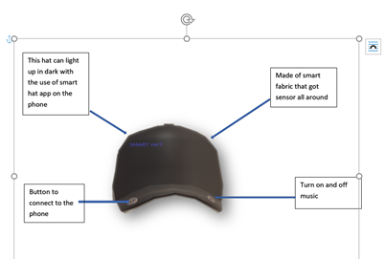

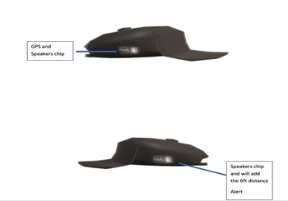

6.1.6. Goals and Constraints

6.1.6.1. Iteration Phase Goals

6.1.6.2. Elaboration Phase Goals

6.1.6.3. Constraints

6.2. Elaboration I

6.2.1. Architecture Diagram

6.2.2. Use Cases

• BlackBox – For all FR

• Brief Use Case - For all FR

• Casual Use Case - For all FR

• Operation Use Case - For all FR

• Fully Dressed Use case - For all FR

• Contracts - For all FR

6.2.3. Context Diagram- Only one for the system

6.2.4. Use Case Diagram of Entire System- Only one for the system

6.2.5. Sequence Diagrams - For all FRs

6.2.6. Package Diagram – As needed

6.2.7. Activity Diagram – As needed

6.2.8. State Chart Diagram – As needed

6.2.9. Conceptual Class Diagram – One for the system

6.2.10. CRC Cards

6.2.11. Domain Model – Only one for the system

6.2.12. Class Diagram – Only one for the system

6.2.13. Object Diagram – Only one for the system ( not part of Project 1 )

**Project 2**

7. Iteration II

7.1. Inception II

7.2. Elaboration II

7.2.1. Architectural Layer Refinement

7.2.2. CRC Cards

7.2.3. Sequence Diagrams

7.2.4. Interaction Diagram - With Visibility Should be translated to code (Bring it back to UML Diagram)

7.2.5. Component Diagram

7.2.6. Package Diagram

7.2.7. Activity Diagram

7.2.8. State Chart Diagram

8.2.7. Class Diagram

8.2.8. Design Class Diagram – With Visibility Should be translated to code (Bring it back to UML Diagram)

8.2.9. Class Diagram (GRASP)

8.2.10. Object Diagram

8.2.11. Deployment Diagram

8.2.12. Reverse Traceability Matrix

**8.** **Other Requirements (Project 1 and Project 2)**

8.1. Supplementary Specification

8.2. Glossary